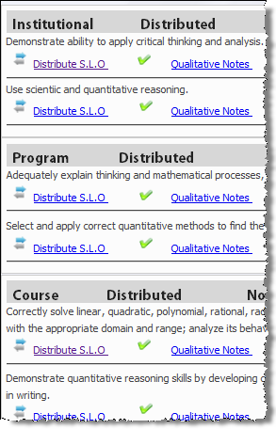
To all Coastline Faculty,
[Type a quote from the document or the summary of an interesting point. You can position the text box anywhere in the document. Use the Drawing Tools tab to change the formatting of the pull quote text box.]

This is a reminder to set up your SLOs in Seaport³
so statistics and reports can be generated at the
end of the term as part of the accreditation process.
There are two steps in setting up your SLOs in Seaport.
- Setup your Seaport³ grade book
(Assessments List and Grade book Grades)
- Distribute SLOs

To access the Seaport³ How-To guides,
- go to the Coastline College home page, (http://coastline.edu),
- click “Faculty & Staff,”
- click “OLIT Faculty/Staff Support,”
- and then under Seaport³ click “Read More.”

If you still need help setting up your SLOs, please contact your mentor or attend a SLO workshop. You can sign up for a SLO workshop at the OLIT Faculty/Staff Support website (under Events). As always, Sylvia Amito'elau and Mark Worden are available to offer assistance at College Center, DL Office, Mon. – Thurs., 714-546-7600 x16594.

This is a task mandated within the accreditation process.
It is not a choice, but rather a must do.
Below is the link to register for training, if you have not already setup your
SLOs. There will be ten different dates and times to choose from.
http://159.115.100.11/regmanager/

Please help Gayle through this critical step in our accreditation process by taking individual responsibility to sign up for a training session, or finishing the distribution of SLO’s if you have already begun to do so. Thank you for taking this seriously and completing your responsibility related to SLO’s and Assessment.

Please contact Gayle Berggren, if you have any questions.
(gberggren@coastline.edu or 714-241-6251)

